

|  |  |
| --- | --- |
| Game:  Ion | Design Team:  Robert Morgan |
| Description:  Ion is a combination space skirmish and strategy game.  Skirmish stage - Players will be able to customise the load outs of a variety of ship hull sizes and designs, choosing from a variety of weapon types as well as engines, armour, shields and special powers.  They will then use these ships to fight each other in a small arena which may contain hazards such as asteroids, planets and nebula.  Strategy stage – Players will need to deploy various ships to their planets from a set number of resources per turn and will be able to attack the other players planets. When an attack occurs these battles will be determined using the skirmish stage in 1 v 1 battles until one player has no ships left at that planet. | |
| Game Objects:  • Ships of various sizes  • Various types of weapons and ship components  • Planets  • Asteroids | |
| Sounds:  • Background music for both the strategy sections and skirmish  • Weapon sounds  • Explosions  • Menu sounds (i.e clicking on buttons) | |
| Controls:  The ships will be controlled by either the arrow keys or wasd. They will also have fire  weapon key and special power key.  The ship building section will be done using the mouse to drag and drop components onto the ships.  The strategy section will also be controlled by the mouse to perform the various selection actions. | |
| Game Flow:  There will be two game modes to choose from at the main menu, conquest and skirmish.  Skirmish – players will choose a number of ships (3) which they will then fight each other with until one player loses all their ships.  Conquest – players will have a time limit to decide how they want to build and deploy ships around their planets. When players ships come into contact around one of the planets the | |

skirmish mode will be used to determine who retains control of it. Play will then go back to the strategy section and this pattern will continue until one player controls all the planets or admits defeat.

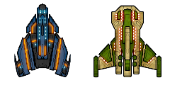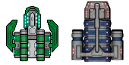

Levels:

• Various arrangements of planets for conquest mode

• Several different arenas (solar systems) for skirmish mode

Resource examples:

Possible styles for ship design

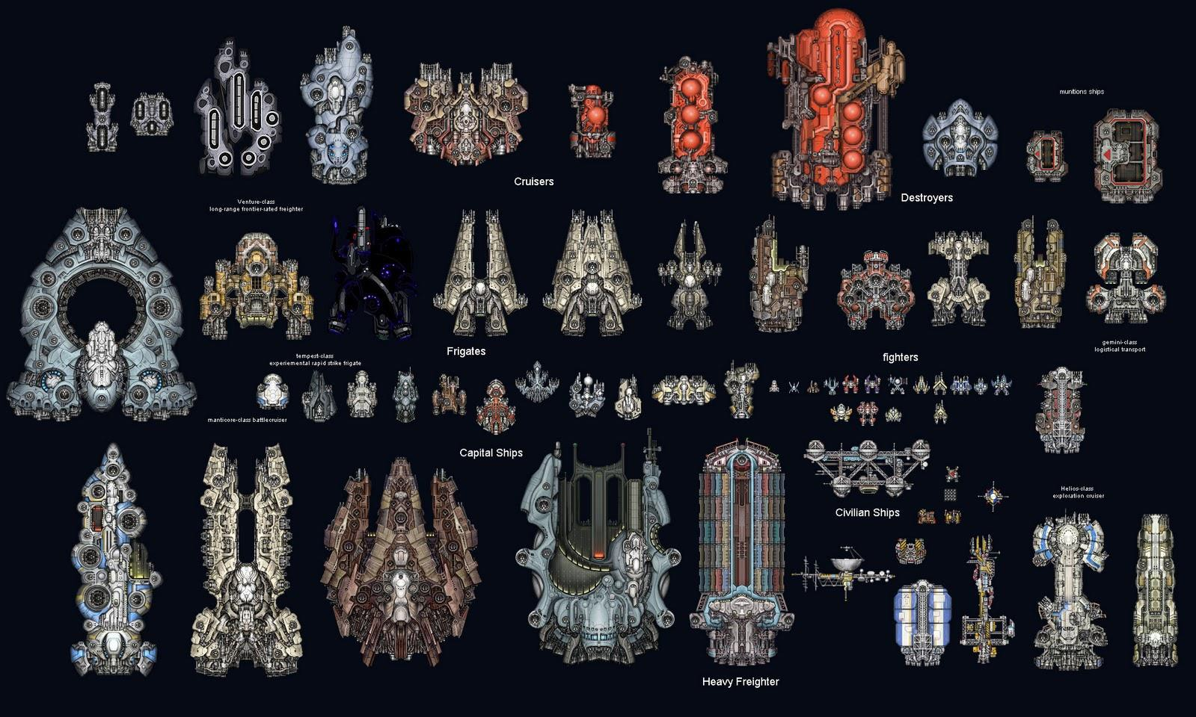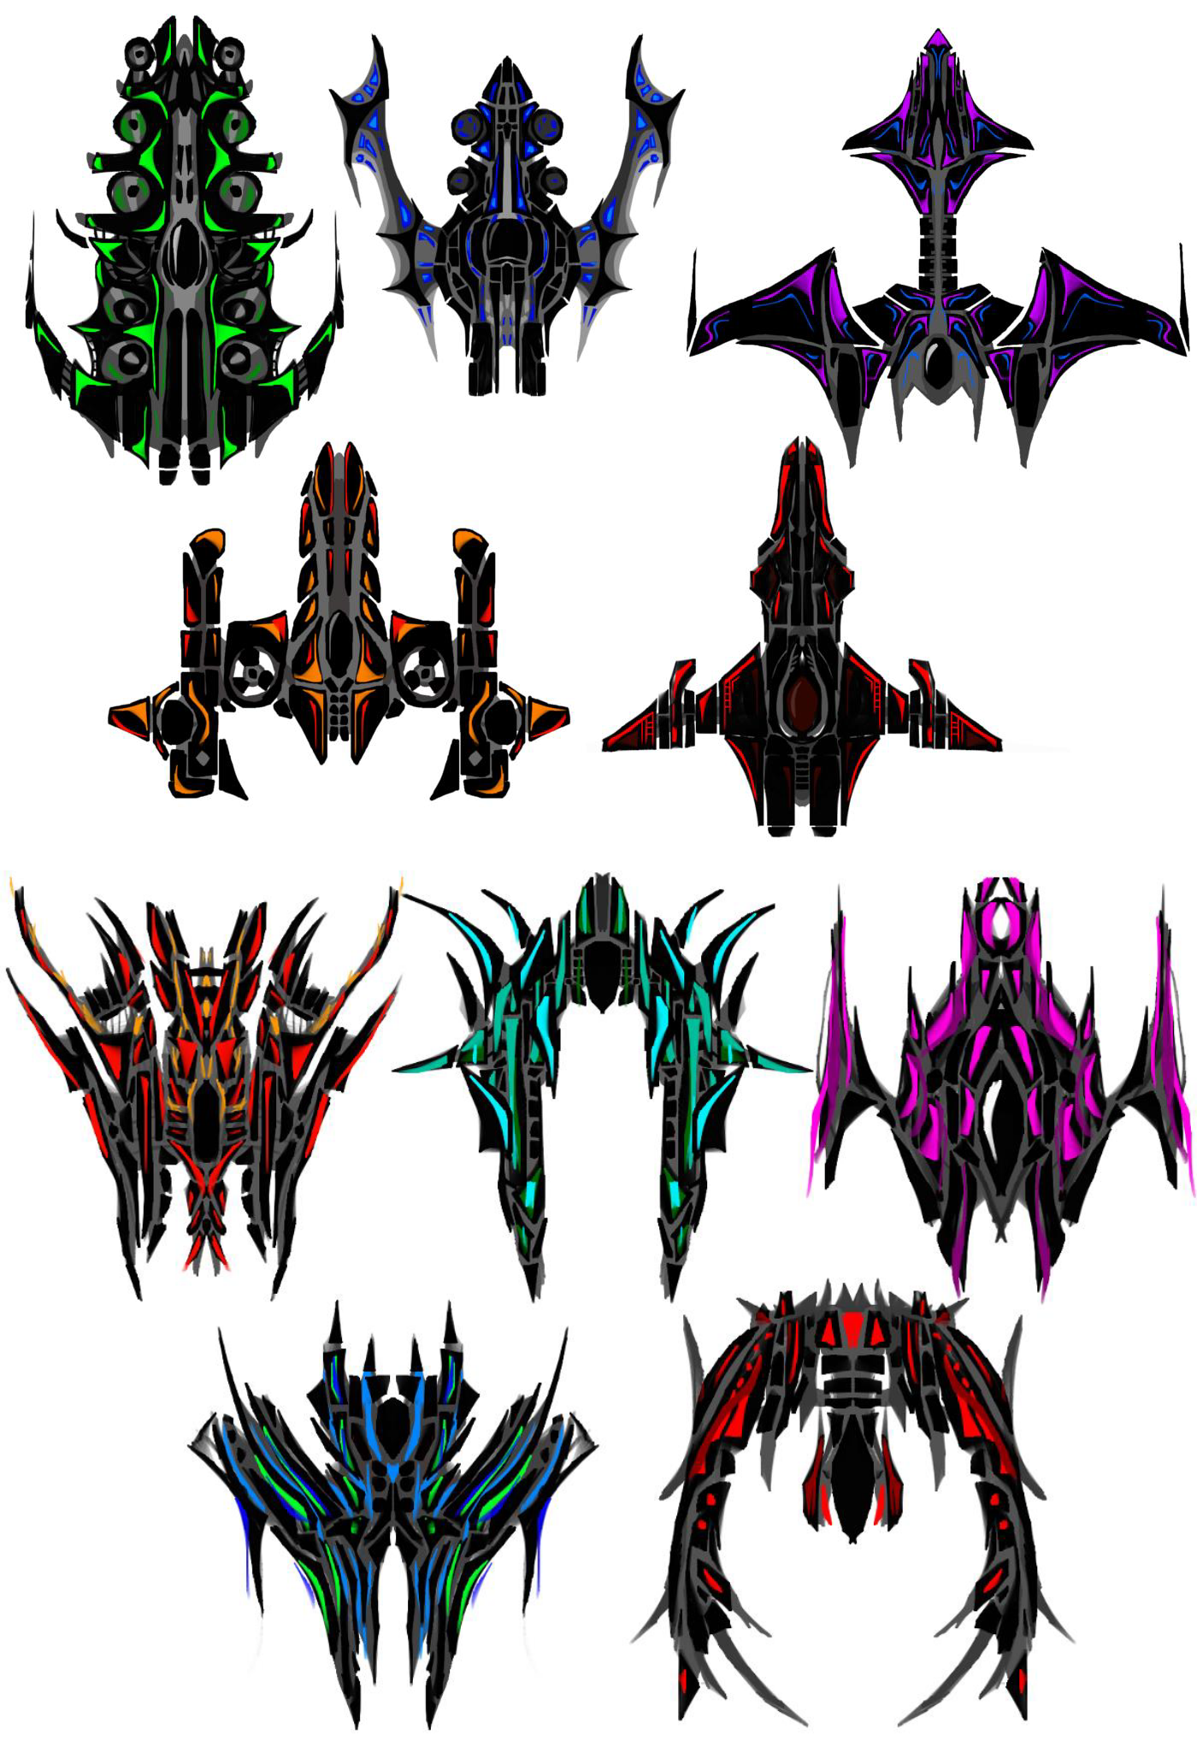

**Weapons**

